**+Roll No: 2003154**

**Lab Final**

**Lab Task Q[1]**

**Question:**

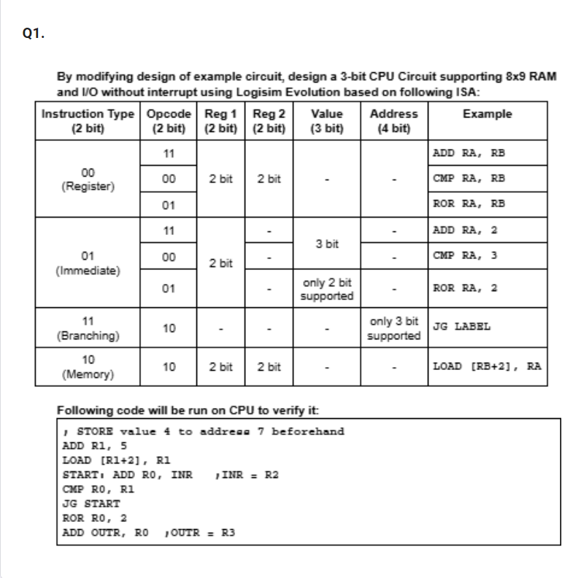

**Solution (Code/Add all circuits diagrams):**

|  |
| --- |
|  |
|  |
|  |
|  |
|  |
|  |
|  |
|  |
|  |
|  |
|  |
|  |

**Output/Simulation Result (Screenshot/SnapShot):**

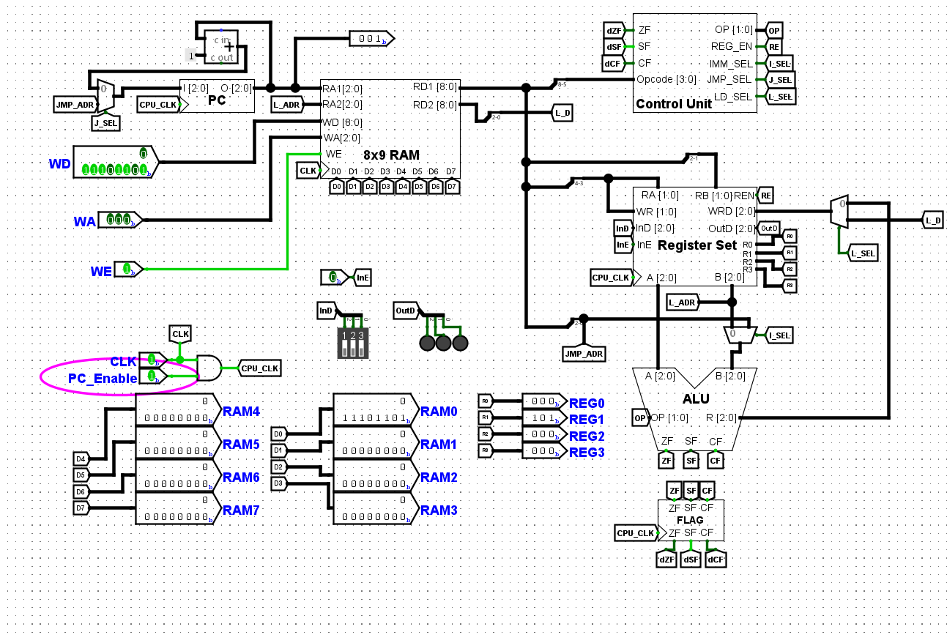

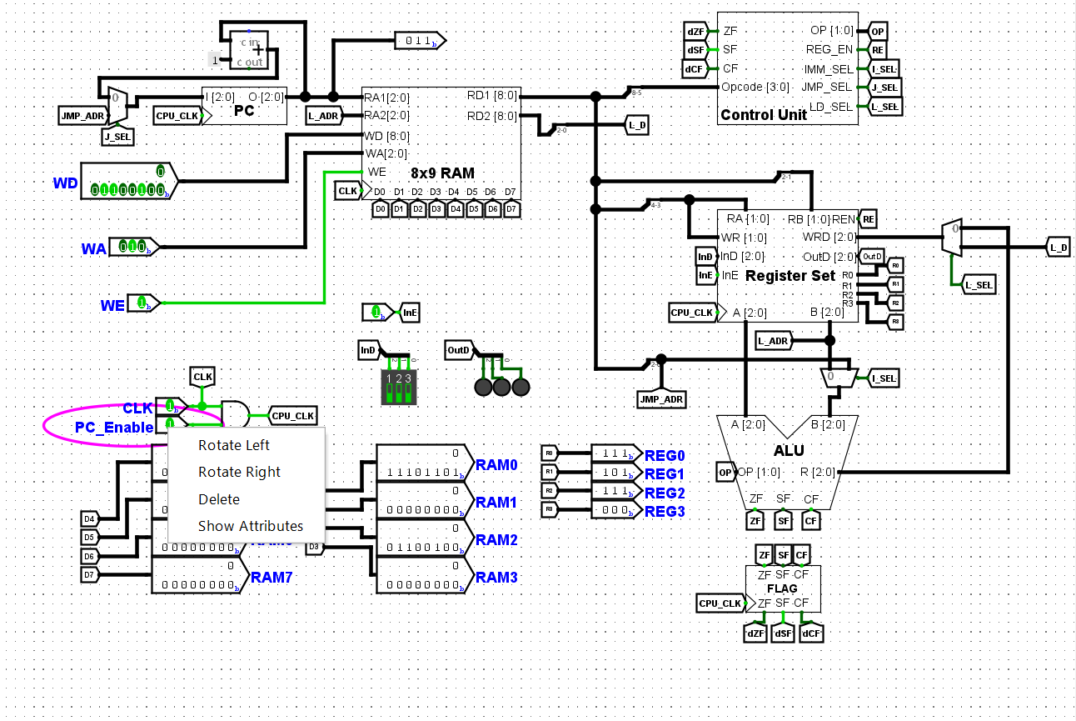

**Roll No: 2003154**

**Lab Final**

**Lab Task Q[2]**

**Question:**

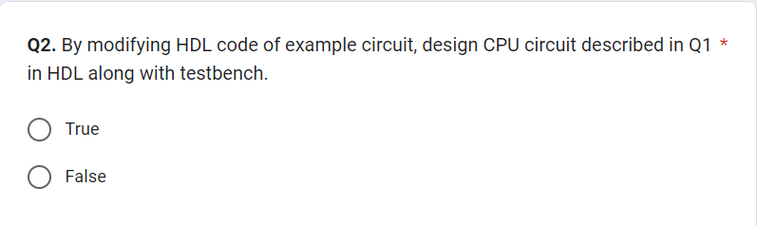

**Solution (Code/Add all circuits diagrams):**

|  |
| --- |
|  |

**Output/Simulation Result (Screenshot/SnapShot):**